HOTEL QUESTIONNAIRE

To assist LENDER in evaluating your hospitality financing proposal, we require the following information:

1. Purpose of loan:
a). Purchase - (Please attach copy of buy/sell contract)
Explain why property is being sold:
What are the franchisors requirements for transferring the property? (Attach a copy of punchlist if applicable)
b). Refinance of Existing Loan
Please attach copies of notes and security documents and explain reasons for refinancing.
c). Renovations
Are renovations required by franchisor? Yes No If yes, please attach franchisor punchlist with bids d). New Construction
Please attach copies of construction bids, FF&E and land contract, if available. Please advise as to the timetable when these items will become available.
2. Hotel information:
a). Total number of rooms Size of rooms  x  Number of stories Number of buildings
Number of Singles Kings Doubles Suites Handicapped Weeklies(if any)
Weekly rate Rooms out of service (Attach list of repairs needed to reopen these rooms)
b). ADR for past 12 months (if applicable) $ Occupancy %
c). Total square footage of land Leased? If leased, attach copy of lease.
d). Was the building constructed prior to January 1, 1981? Yes No
e). If yes, has the building been tested for Asbestos containing materials (ACM), lead-based paint, or lead in drinking water? Yes No Describe (or attach ESA)
f). Are there any known or suspected environmental problem areas on the property? (i.e. asbestos or underground gasoline storage tanks) Yes No If Yes, please explain g). Are any operations and maintenance plans (O&M plans) in effect at the facility?
h). Construction:

Exterior:
Brick Concrete Block Prefab Stucco Other Yr. Constructed
Bldg 1
Bldg 2
Bldg 3
Bldg 4

Roofing:
Shingle Metal Tile Flat Pitched Age of roof
Bldg 1
Bldg 2
Bldg 3

Parking Lot:
Concrete Asphalt No. of spaces
Describe condition:
Interior:
Interior corridor Exterior corridor Elevators (Y or N)
Bldg 1
Bldg 2
Bldg 3
Bldg 4

Number of meeting or banquet rooms Description and capacity Swimming pool (Yor N) Truck parking (Yor N)
Restaurant (Yor N) If yes, is it Leased Closed Owner operated Description and capacity Terms What includes Lounge (Yor N) If yes, is it Leased Closed Owner operated Description and capacity Terms What includes
Televisions:
No. of units
Brand Name
Age
Remote (Yor N)

HVAC: Central Individual Units
No. of units
Brand Name
Age

Bathroom description (i.e. flooring, tubs, ceilings, etc.)
Reservation system description
Other computer system description
Telephone system description
If any of the following items are leased or to be leased within the next 12 months, mark below and attach copies of leases.
TV's Telephones Reservation system
Signs Furniture Phone system

Date and summary of scope of last renovation
3. Hotel location:
Physical address of property Nearby highways Street in front of property:
One way - Yes No How many lanes? Direct access - Yes No
Turning lane - Yes No Speed limit
Hotel traffic:
Destination % Transient % Tourist % Local %
Any construction being performed on this road now or being planned in the future? If so, to what degree? Are there any drainage problems? If so, please explain
Competitors:
Name Rooms Property age ADR Occupancy Distance away
1.
2.
3.
4.
5.
6.
Are you aware of any to-be-completed properties which will compete with this property? Yes No
If yes, please describe

Restaurants: Gas Stations:
Name Distance away Name Distance away
1. |  |  | 1.
2. |  |  | 2.
3. |  |  | 3.
4. |  |  | 4.

Describe in detail other businesses in the area:
Are there any Adult Entertainment businesses nearby? Yes No If yes, detail
In detail, please draw a map of the area indicating property, nearby highways, competitors, access to property, etc. (See Example)

Example:
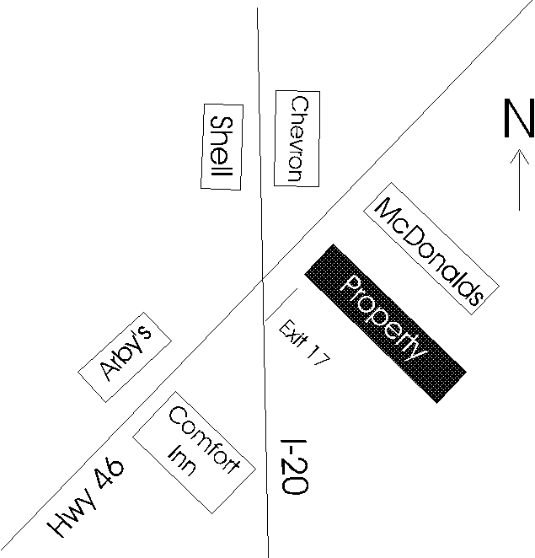

Items to attach:
A). Pictures of property
including: 1. Outside - All sides 2. Rooms - All types 3. Bath area 4. Hallways
5. Lobby 6. Pool area
7. View on street facing across street 8. View on street facing to the left 9. View on street facing to the right 10. View of property from highway
B). Recent appraisals (if available)
C). Last franchise inspection report

Signature Date

Motel questionnaire safe.doc

